

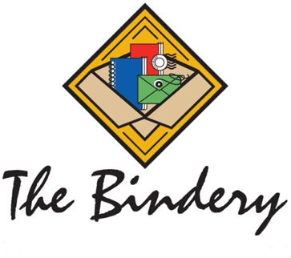
www.TheBinderyMN.com

Materials Received

TheBinderyMN.com
We appreciate your business. We will keep you updated on the progress of your project.
The Bindery Team

If you have questions or need to change any details, please contact your Account Services Manager

The following materials have been received for your PO number:

shrink-wrapping – eyeleting – drilling – kitting and fulfillment
wire binding – plastic binding – perfect binding – collating - cutting
www.TheBinderyMN.com

